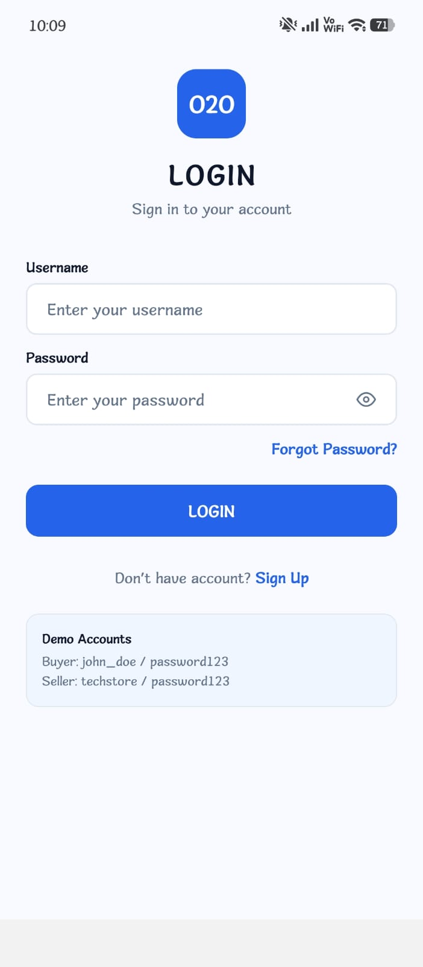
Remove demo accounts from here only in frontend
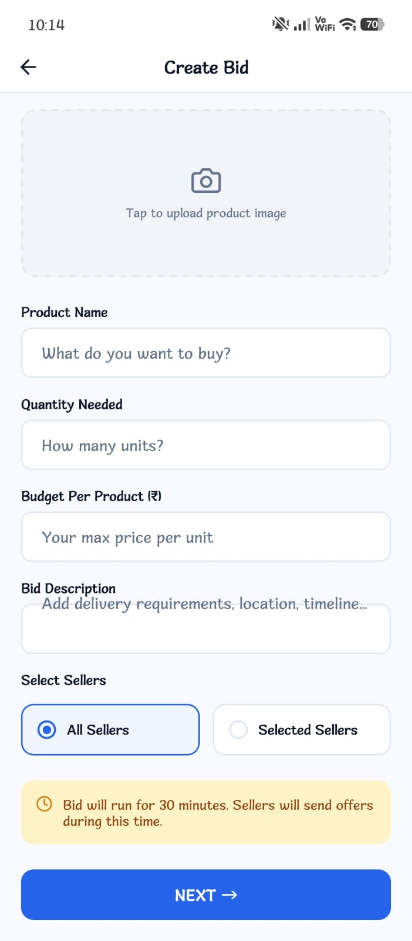
From here at bid description set this sentences and here bid is not sharing please do perfect to the bid
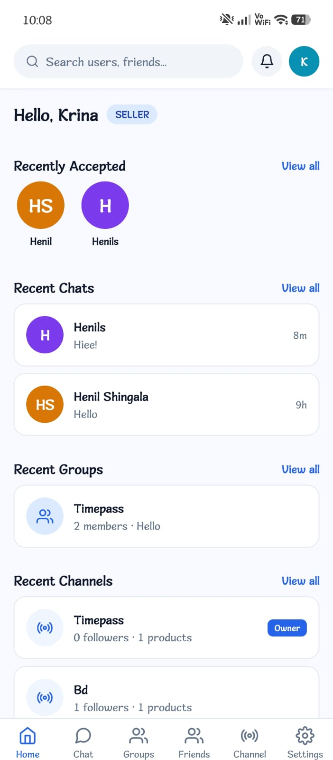
Here at all the places where you see view all there when user et chats if 1 is unread then write view all(1) use this example at here
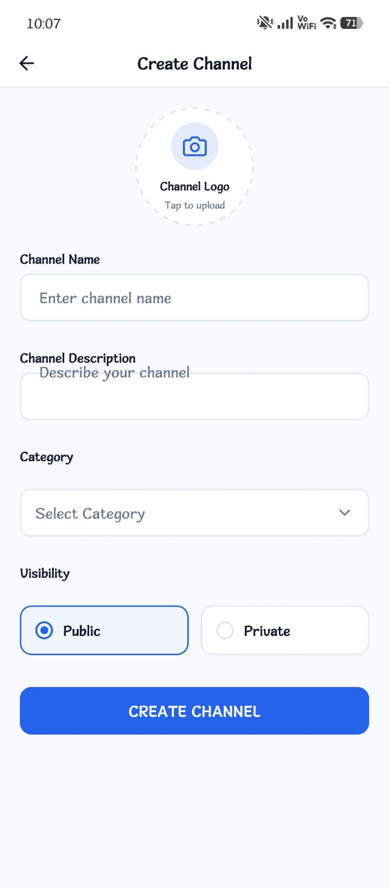
Here I can not add logo and also set channel description perfect
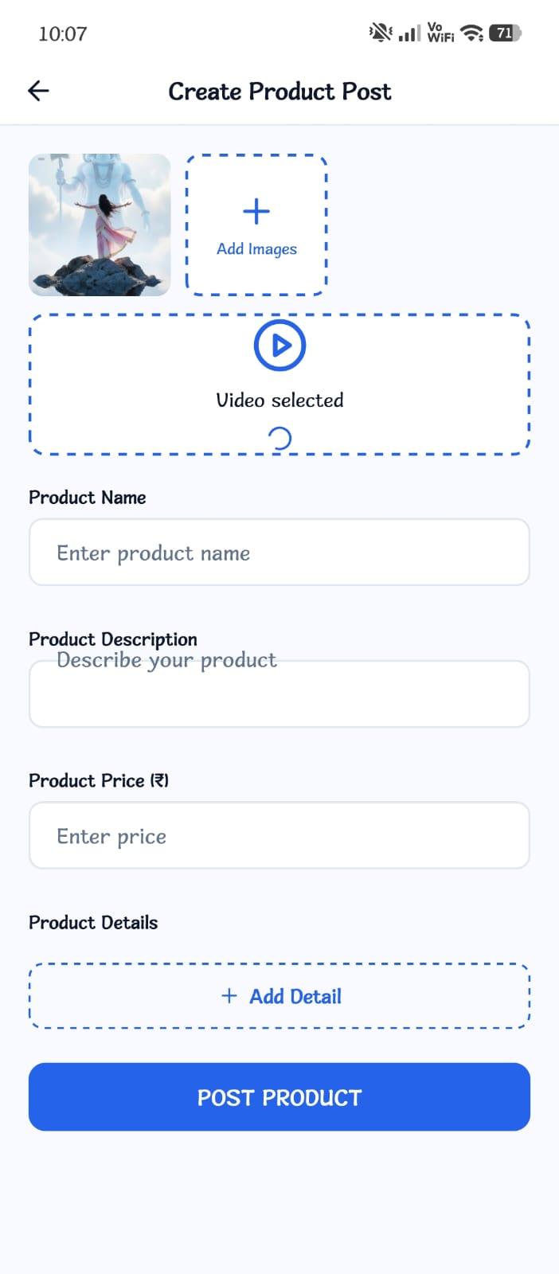
Here I can only add images and videos but customer can not see that and also do set product description
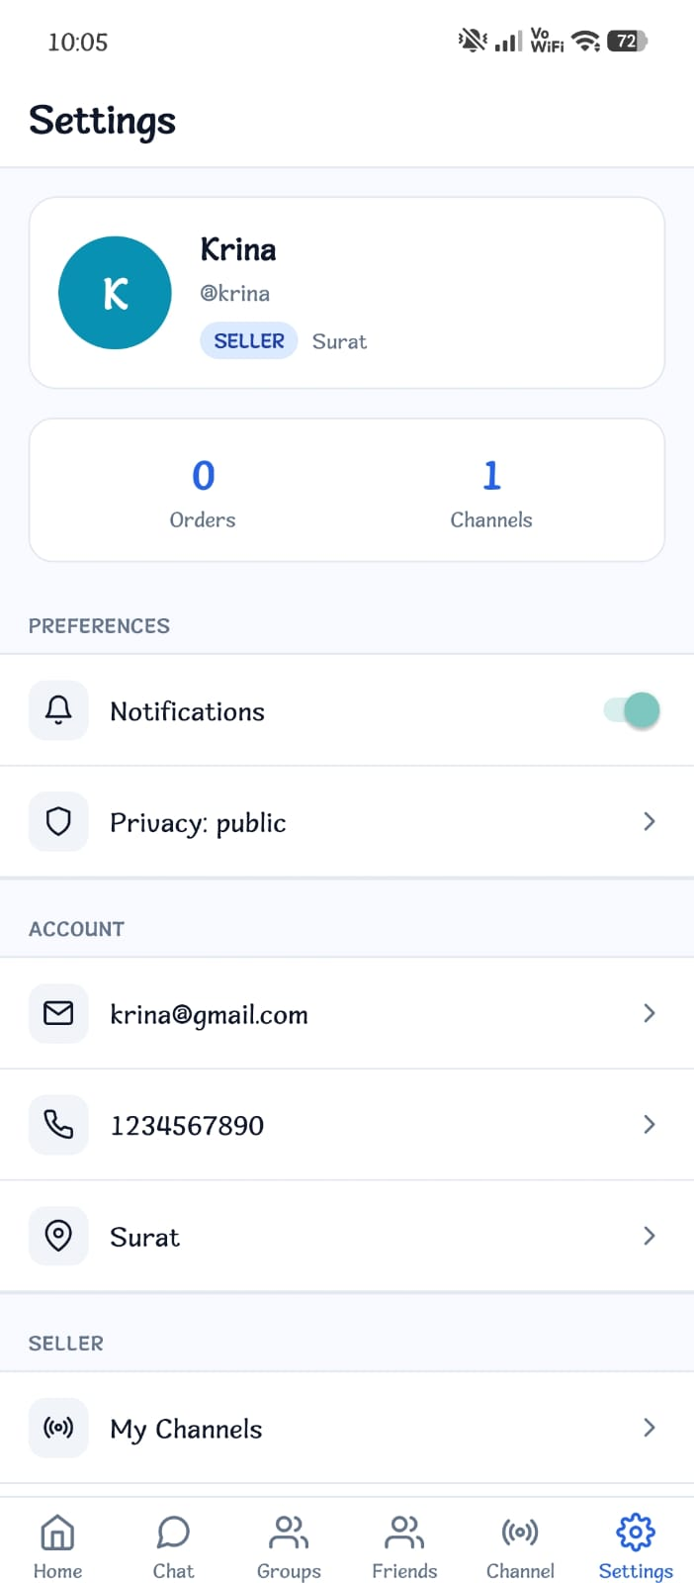
Here add location at there and in buyer at settings add my wishlist and also do perfect wishlist just like flipkart
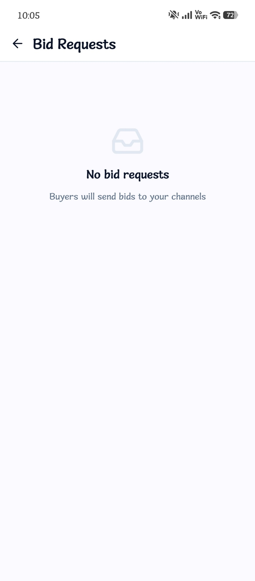
But here I am not getting bid requests from buyer make it perfect make bid all perfect
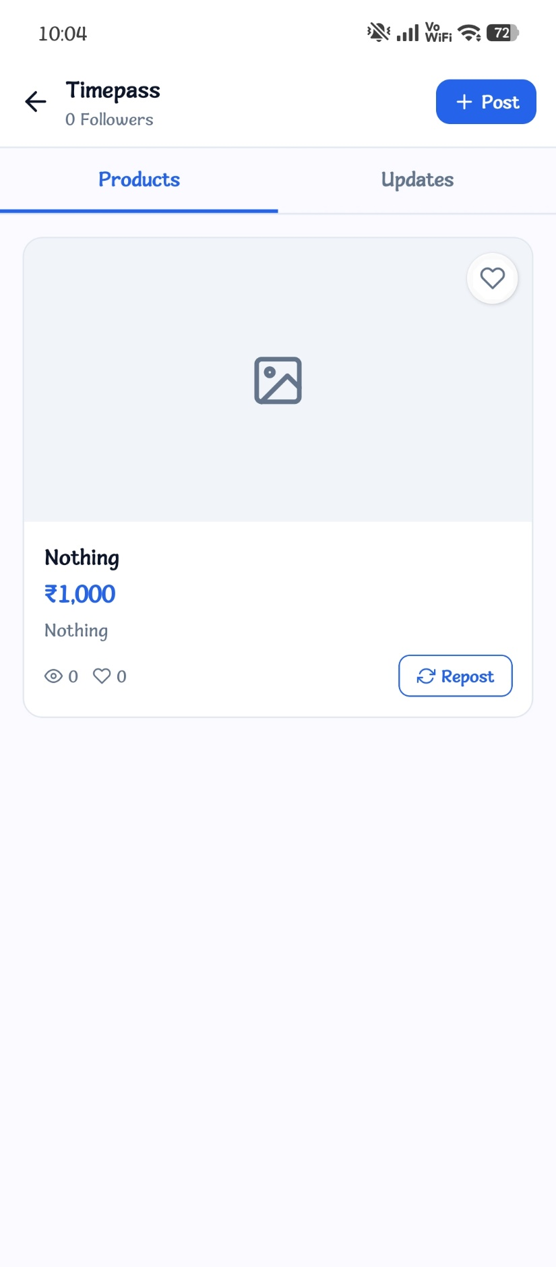
Add post image at there
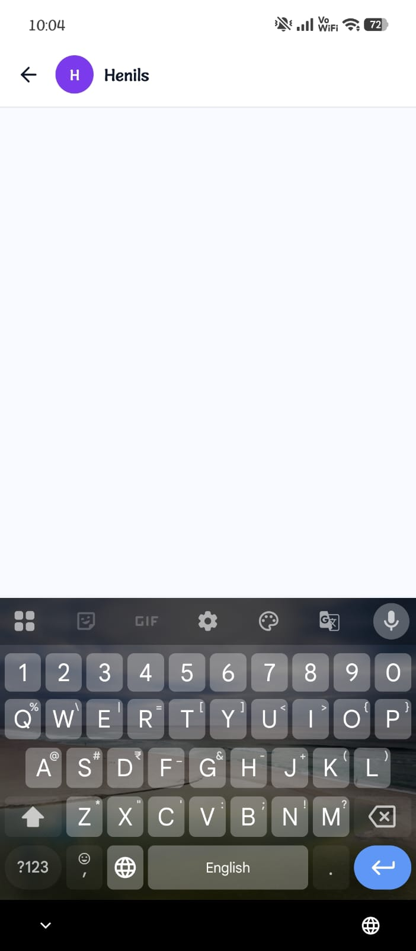
Here add typing bar at there in chat
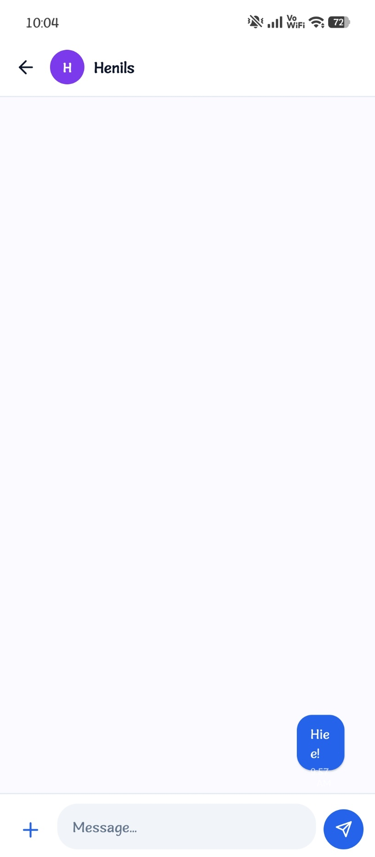
Here in chats do full line of chat not like this just like snapchat or whatsapp I want Hiee! In 1 line not Hie and e! in different lines

